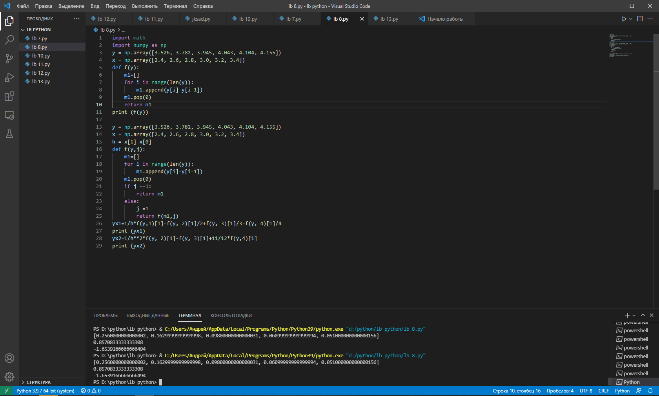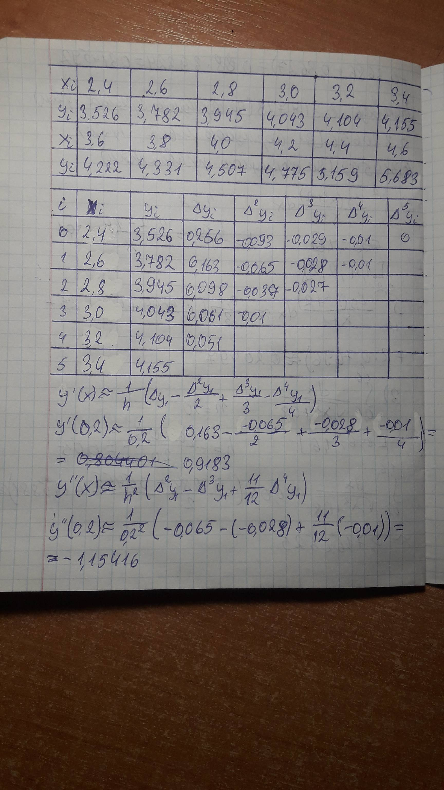

import math

import numpy as np

y = np.array([3.526, 3.782, 3.945, 4.043, 4.104, 4.155])

x = np.array([2.4, 2.6, 2.8, 3.0, 3.2, 3.4])

def f(y):

    m1=[]

    for i in range(len(y)):

        m1.append(y[i]-y[i-1])

    m1.pop(0)

    return m1

print (f(y))

y = np.array([3.526, 3.782, 3.945, 4.043, 4.104, 4.155])

x = np.array([2.4, 2.6, 2.8, 3.0, 3.2, 3.4])

h = x[1]-x[0]

def f(y,j):

    m1=[]

    for i in range(len(y)):

        m1.append(y[i]-y[i-1])

    m1.pop(0)

    if j ==1:

        return m1

    else:

        j-=1

        return f(m1,j)

yx1=1/h\*f(y,1)[1]-f(y, 2)[1]/2+f(y, 3)[1]/3-f(y, 4)[1]/4

print (yx1)

yx2=1/h\*\*2\*f(y, 2)[1]-f(y, 3)[1]+11/12\*f(y,4)[1]

print (yx2)